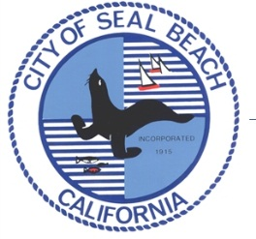
PRESS RELEASE

Seal Beach Police Department
911 Seal Beach Blvd
Seal Beach, CA 90740

March 30, 2016 Contact: Sgt. Mike Henderson
Phone: (562) 342-7391

FOR IMMEDIATE RELEASE Email: mhenderson@sealbeachca.gov

Seal Beach Police to Take Back Unwanted Prescription Drugs

Seal Beach, CA. – On April 30 from 10 a.m. to 2 p.m. the Seal Beach Police Department and the Drug Enforcement Administration (DEA) will give the public its 11th opportunity in six years to prevent pill abuse and theft by ridding their homes of potentially dangerous expired, unused, and unwanted prescription drugs. Bring your pills for disposal to the Leisure World Retirement Community – FRONT GATE at 13533 Seal Beach Bl.. (The DEA cannot accept liquids or needles or sharps, only pills or patches.) The service is free and anonymous, no questions asked.

Last September, Americans turned in 350 tons (over 702,000 pounds) of prescription drugs at more than 5,000 sites operated by the DEA and more than 3,800 of its state and local law enforcement partners. When those results are combined with what was collected in its 10 previous Take Back events, DEA and its partners have taken in over 5.5 million pounds—more than 2,750 tons—of pills.
This initiative addresses a vital public safety and public health issue. Medicines that languish in home cabinets are highly susceptible to diversion, misuse, and abuse. Rates of prescription drug abuse in the U.S. are alarmingly high, as are the number of accidental poisonings and overdoses due to these drugs. Studies show that a majority of abused prescription drugs are obtained from family and friends, including from the home medicine cabinet. In addition, Americans are now advised that their usual methods for disposing of unused medicines—flushing them down the toilet or throwing them in the trash—both pose potential safety and health hazards.
For more information about the disposal of prescription drugs or about the April 30 Take Back Day event, go to the DEA Diversion website.

# # #

